Readme How To add new branch & directories to GIT

cd GitPythonPrj

dir

git init

git branch -M newpython

git checkout newpython

git status

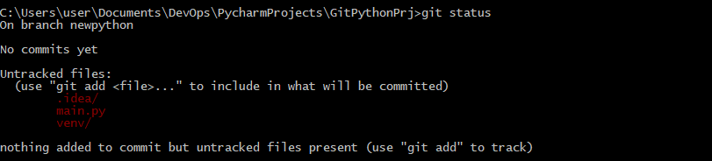

git add .

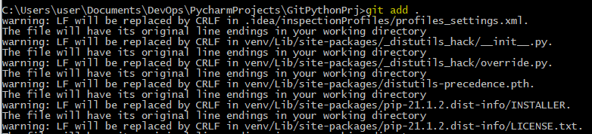

git status

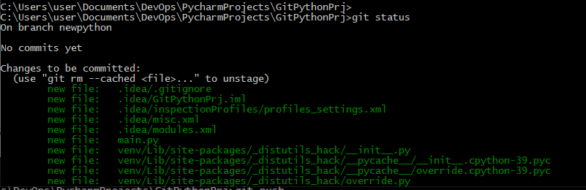

git commit -m "Python commit"

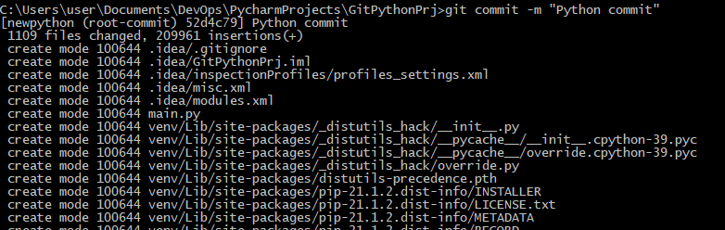

git remote add newpython [git@github.com:smavash/GitHW_ex7.git](mailto:git@github.com:smavash/GitHW_ex7.git)

git push --set-upstream origin newpython

